October 2023 Billing Newsletter

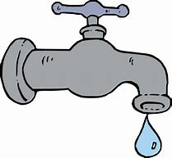
Water System Update: The new filters are installed, and pilot testing will begin as soon as basic electrical to the filters is complete. After pilot testing, the basin and reservoir will be cleaned; then a full system flush will be done. We will keep you updated as we continue to transition to full operation. This process may still take a couple of months, thank you for your patience.

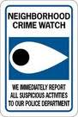
Neighborhood Watch: Be mindful that there have been reported vehicle break-ins, drug activity, and tents for homeless set up in the community. Keep your cars, doors and windows locked. Turn lights on or use motion sensor lighting. Would-be thieves most often exploit opportunities like items left in vehicles, cash, checks, gift cards and packages left in mailboxes and on doorsteps. Delivery vehicles may also be followed. We need all members of the community to become more aware; watch for and report violators or suspected violators.
When in doubt, report suspicious persons or activity to 911.

During a power outage, it is important to prioritize safety and take necessary precautions. Prepare by storing a supply of water to meet your needs. The generator repairs are not complete; therefore, the possibility of no water during a power outage is still likely. Here are some tips to help you stay safe and prepared:
- 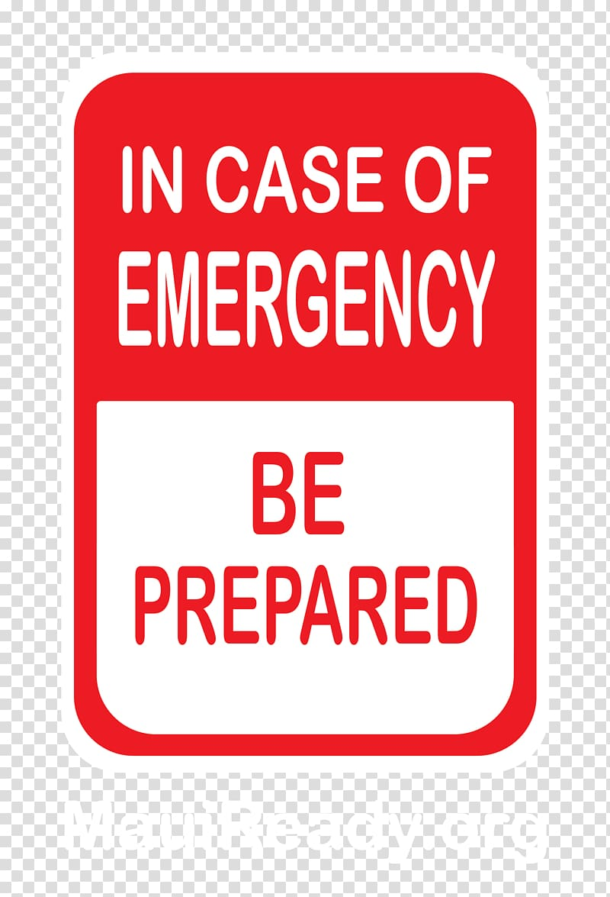Keep freezers and refrigerators closed: This will help maintain the temps inside & prevent food spoilage.
- Avoid using gas stoves or ovens to heat your home: These appliances are not designed for heating purposes and can lead to carbon monoxide poisoning.
- Disconnect appliances and electronics: This will protect them from potential damage caused by electrical surges when the power is restored.
- Use generators safely: If you have a generator, make sure to use it outdoors and away from windows to prevent carbon monoxide buildup.
- Stay away from fallen power lines: Keep a safe distance of at least 35 feet and report any downed power lines to the authorities.
- Having an emergency kit with essential supplies such as water, flashlights, batteries, and first aid items can make a difference in such situations, stay safe and take care!
Slow down and be alert! Kids are excited on Halloween and may dart into the street. Turn on headlights early in the day to spot kids from further away. Carry glow sticks or flashlights, use reflective tape or stickers on costumes and bags, and wear light colors to help kids see and be seen by drivers. When selecting a costume, make sure it is the right size to prevent trips and falls. Choose face paint over masks when possible. Masks can limit children’s vision. Trick or treat with friends or family members, and never go alone.
On October 14, 2023, an annular solar eclipse will create a “ring of fire” in the sky from Oregon to Texas. Remember to never look directly at the sun without protection designed for solar viewing.
Pier update: The float was returned to Coupeville Wharf for winter storage. The pier remains open year-round for members and their guests.

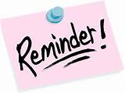
Board of Trustee meetings are held the 2nd Tuesday of every month. The next one is scheduled for Tuesday, October 10, 2023 at 7pm at the clubhouse. All members are invited and encouraged to attend.

