**June 2023 Billing Newsletter**

**j0095353Mowing Policy**—All lots must be mowed at least twice per year. The first mowing in May and by June 1st, the second by August 1st. The first mowing of vacant lots is underway and should be completed soon. It is every owner’s responsibility to keep their entire lot free of the tall grasses and noxious weeds. This includes along fences, all property lines and around water meters. If you are not keeping up with your own **ditch maintenance**, please call the Island County Road Dept. at 360-675-2004 and let them know the ditches that need to be mowed in your area.

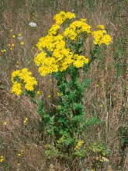**Noxious Weeds**: Look in your yards and ditches, you’ll likely see some of these weeds lurking there. Several noxious weed species were identified in our yards, and ditches all over the community including Canada Thistle, Tansy Ragwort & Poison Hemlock. Tansy Ragwort, appears as a daisy-like bunch of yellow flowers atop a tall stalk. Poison Hemlock is a tall plant with white rosette flowers and purplish blotches on the stalk. All parts of these plants are poisonous to people & pets. Infestations can be controlled manually by pulling up the entire plant, including its roots while wearing protective gear. Flowering plants should be sealed in a plastic bag and put in the trash, not in compost or yard waste. Plants continue to be poisonous for up to 3 years! Plants will often have enough energy to still mature to seed stage even after being pulled or cut. Because of Tansy Ragwort’s & Poison Hemlock’s invasiveness and toxicity, they are Class B regulated weeds, meaning property owners are legally required to control them. They are 2 of the county’s most pervasive noxious weeds. For more information on these and other noxious weeds, visit [*www.nwcb.wa.gov*](http://www.nwcb.wa.gov)

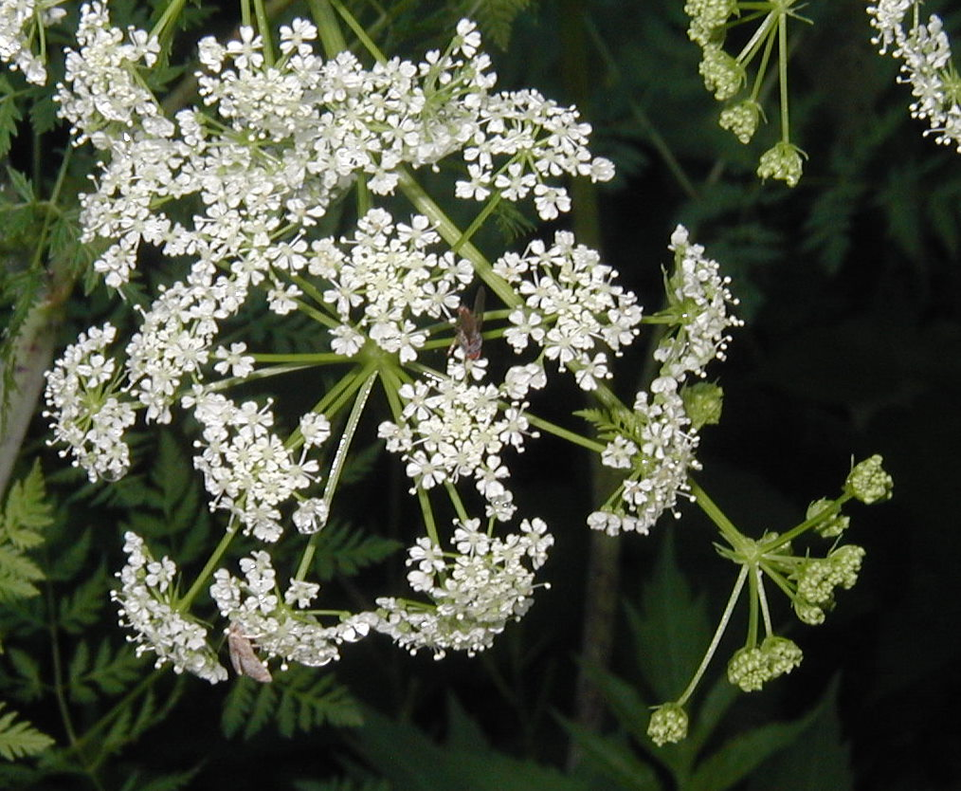

**The pool is open for the summer beginning Friday, June 16, 2023 thru Labor Day.** A pool card is required to use the facility. If you have already filled out the pool application and signed the liability waiver form, your **Pool Card** is included in this mailing. The pool is available for Private Rentals on Thursday afternoons and after the pool closes. Call the office if you would like more informaiton.



**Fireworks season is upon us.** This is a friendly reminder of the rules of etiquette regarding them.



There are **no fireworks** allowed at any community properties. This includes all streets, the beach, the pool & clubhouse, baseball field, basketball court, clubhouse parking lot & the office. If you use fire-works on your own property; please **clean up your fireworks debris** including the ditches and street. **Legal Fireworks** are permitted on private property during Island County designated times. Discharge times are July 3rd 9am -11pm, July 4th 9am-midnight, July 5th 9am -11pm. Burn bans may also prohibit the use of any fireworks. Violators will be reported to the Island County Sheriff.

**The next Board of Trustees meeting is scheduled for Tuesday July 11, 2023** at the clubhouse. The June 13th Board Meeting is cancelled because of the June 3rd annual Meeting. All members are invited and encouraged to attend on July 11th at 7pm.