**Please take some time to clear around your water meters-**

**Spring growth has covered a lot of them.**

**June 2022 Billing Newsletter**

**Fireworks season is upon us.** This is a friendly reminder of the rules of etiquette regarding them.

There are **no fireworks** allowed at any community properties. This includes all streets, the beach, the pool & clubhouse, baseball field, basketball court, clubhouse parking lot & the office. If you use fire-works on your own property; please **clean up your fireworks debris** including the ditches and street. **Legal Fireworks** are permitted on private property during Island County designated times. Violators will be reported to the Island County Sheriff.

**Mowing Policy**-- The first mowing of vacant lots is underway and should be completed soon. It is every owner’s responsibility to keep their entire lot free of the tall grasses and noxious weeds. This includes backyards, along fences, all property lines and around water meters. Additionally, if you are not keeping up with your own **ditch maintenance**, please call the Island County Road Dept. at 360-675-2004 and let them know the ditches that need to be mowed in your area.

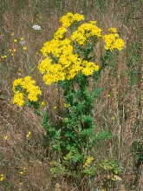**Noxious Weeds**: Take a look in your yards and ditches, you’ll likely see some of these weeds lurking there. While reading meters this month, several noxious weed species were identified in our yards, and ditches all over the community. Tansy Ragwort, appears as a daisy-like bunch of yellow flowers atop a tall stalk. Poison Hemlock is a tall plant with white rosette flowers and purplish blotches on the stalk. All parts of these plants are poisonous to people & pets. Infestations can be controlled manually by pulling up the entire plant, including its roots while wearing protective gear. Flowering plants should be sealed in a plastic bag and put in the trash, not in compost or yard waste. Plants continue to be poisonous for up to 3 years! Plants will often have enough energy to still mature to seed stage even after being pulled or cut. Because of Tansy Ragwort’s & Poison Hemlock’s invasiveness and toxicity, they are Class B regulated weeds, meaning property owners are legally required to control them. They are 2 of the county’s most pervasive noxious weeds. For more information on these and other noxious weeds, visit [*www.nwcb.wa.gov*](http://www.nwcb.wa.gov)

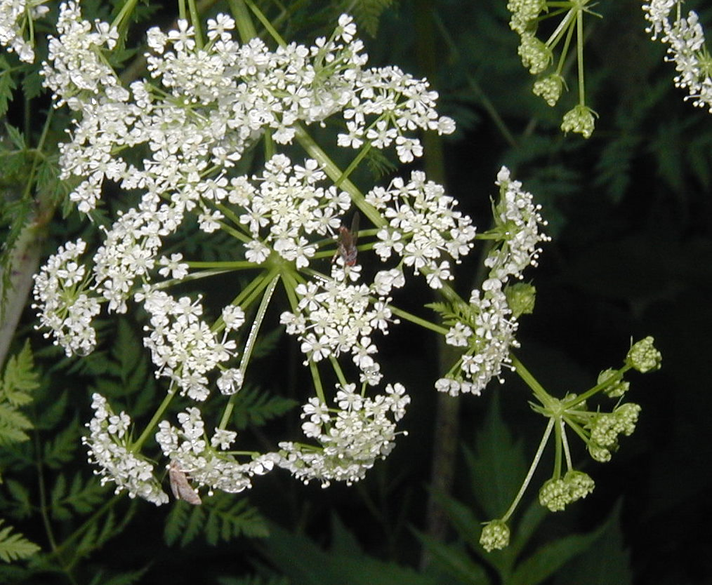

The float is in place and ready for use. This facility is for day use only. There is no overnight moorage!

The Annual Pier Inspection will be June 15 10am-1pm & June 16 11am-1pm. Bring a shovel and gloves to help scrape the pilings. All help is appreciated. We hope to see you there.

MCj03616260000[1]**The pool** will open Saturday, June 18 for the summer. If you recently filled out the pool application and signed the liability waiver form on the back, your **pool card** is included in this mailing. If not, you can pick it up at the office during regular office hours. Lifeguards have been difficult to find this year so some Lifeguard hour sessions may be open swim. If you are concerned call the pool to verify which sessions are available that day. 360-678-4469. Private parties are available on Thursdays and outside the regular schedule. Call the office to schedule. 360+-678-7446

Thank you to those who participated at the annual meeting. It is a great opportunity to get to know your neighbors. Results of the voting for the By-laws Amendment and Budget will be available next week after the ballots are counted & verified.

**Board meetings are held the 2nd Tuesday of the month. The June 14th is cancelled** due to annual meeting on June 4th. The next one scheduled for **Tuesday, July 12, 2022**. All members are invited and encouraged to attend on July 12th at 7pm. The office will be closed on July 4th to celebrate Independence Day.