**November 2021 Billing Newsletter**

MCBL00124_0000[1]**Consider this checklist to begin preparing your home for fall & winter!**

* Clean gutters and install gutter guards to prevent backup when the wet season hits
* Replace the batteries in smoke and carbon monoxide detectors
* Prepare furnaces for increased use with seasonal maintenance, including filter replacement
* Have fireplaces & chimneys cleaned if necessary
* Keep the cold weather out by replacing dry or damaged weather stripping on all doors and windows
* Check all outside water spigots for leaks and put away all water hoses
* Verify all outside wall water pipes are insulated to prevent freezing and burst pipes
* Check all flashlight batteries and stock up on supplies for days with potential power outages
* Prepare generators and give them a test run
* Empty the fuel from summer lawn equipment to prepare for non-usage during winter months
* Clear debris from blocking culverts in your ditch

**j0411558North Whidbey Help House**- If you are in need of a Thanksgiving food basket, registration is **Monday, November 1st thru Friday, November 12th**. Anyone 18 years and older in the household must provide ID including a physical address. Registrations after November 12th will be by wait list. It is anticipated that everyone that needs a basket will receive one. If you have any questions please call the Help House at 360-675-0681.

**Rodents** – During cold weather rats and mice look for shelter in your home and out buildings. Seal all openings as small as ¼ inch. Clean up rubbish piles and use tight fitting lids on garbage cans. Eliminate food sources such as pet food & birdseed. Use the correct sized trap for rats or mice & use plenty of them in active rodent areas.

**The holiday season is nearly upon us!** Be forewarned that **MAIL THEFT** becomes more common this time of year. USPS, UPS and Fed EX vehicles may be followed to steal packages left on doorsteps. You can discourage these thefts by checking your mail every day or have a trusted neighbor collect your mail & packages for you. Consider, your workplace may be a safer location to have packages delivered. Call 911 if you witness mail theft.

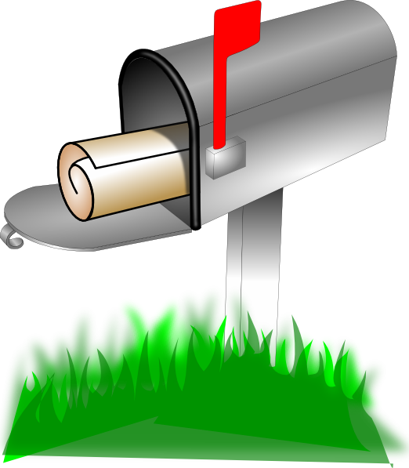

It’s been a tough year for many families, if you are behind on utility payments, call the utility directly or visit [www.utc.wa.gov](http://www.utc.wa.gov) for more information. There are government assistance programs that can help.

**Thanksgiving Office Schedule** - The Rolling Hills-Glencairn Community Service office will be **CLOSED** Thursday, November 25 through Friday, November 26, 2021 so office staff may spend the Thanksgiving holiday with their families. We hope you have a Happy Thanksgiving as well. **Office hours are: 9am-2pm, Monday–Friday (unless otherwise posted).**

****

**Board of Trustee meetings are held the 2nd Tuesday of every month.** The next one is scheduled for Tuesday, November 9, 2021 at 7pm at the clubhouse. All members are invited and encouraged to attend.