

Thank you for your Holiday light displays, they make a lot of people smile!!



**December 2020 Billing Newsletter**

You are responsible for the amount due on this statement. If you are unable to make your monthly HOA & water payments due to the Covid-19 pandemic, please call the office to make payment arrangements. It will be easier to get caught up later on if you continue to make payments now.

****This **h**as been a rough year for all of us and we need to continue watching out for eachother. If you see a need, there are agencies who can help including the Holiday House and the Help House. Reach out if you or someone you know needs assistance.

**Beach parking lot gate**—If your application has been turned in, keycards and parking passes are available for pick up at the office. If you don’t pick up, they may be mailed, but they are bulky and will require an extra mailing. If you can, please stop by and pick them up when you have a minute. If you have lost your application, go to our website **rollinghillsglencairn.com** and print yourself a new one.



[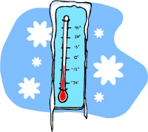](http://pepedamaso6.blogspot.com/)There are water leaks found while reading meters nearly every month. As temperatures drop outside, it is important to know where your water meter is and how to turn it off in case of a leak. If you have questions about this, call the office and we will be glad to show you where your meter is and how to turn it off.

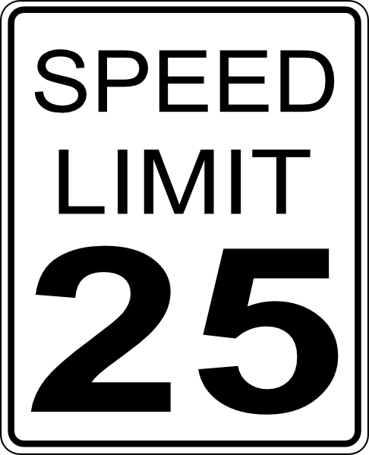

The speed limit is 25 MPH. Please be considerate and safe when driving in our community. We have many children and walkers out on these dark afternoons & evenings. Show you care by slowing down.



**New Year’s Eve Fireworks** are not allowed on the beach or on any Rolling Hills-Glencairn Community properties. This includes the clubhouse area, parking lots, basketball court, baseball field, beach, and picnic area next to the beach. *LEGAL FIREWORKS are permitted only on private property* during Island County designated times. The 2020 allowed fireworks discharge times are Dec 31st & Jan 1st 6pm until 1am.

[](http://www.clipartlord.com/free-cute-christmas-wreath-clip-art/)**Holiday Office Schedule** - The Rolling Hills-Glencairn Community Service office will be **closed** Thursday-Friday, December 24 and 25. The office will also be closed Friday, January 1, 2021 so office staff may spend the holiday with their families. We hope you have a great Christmas and Happy New Year. **Office hours are: 9am-2pm, Monday–Friday (unless otherwise posted).**

****The next Board of Trustees meeting is scheduled for **Tuesday,** **December 8, 2020** at 7pm via ZOOM. Email the office for the link if you are interested in attending. rollinghills@oakharbor.net