**November 2020 Billing Newsletter**

You are responsible for the amount due on this statement. If you are unable to make your monthly HOA & water payments due to the Covid-19 pandemic, please call the office to make payment arrangements. It will be easier to get caught up later on if you continue to make payments now.

**Beach parking lot gate**—If your application has been turned in, keycards will be available for pick up at the office after November 25th or they will be mailed to you with your next bill. If you have lost your application, go to our website **rollinghillsglencairn.com** and print yourself a new one.

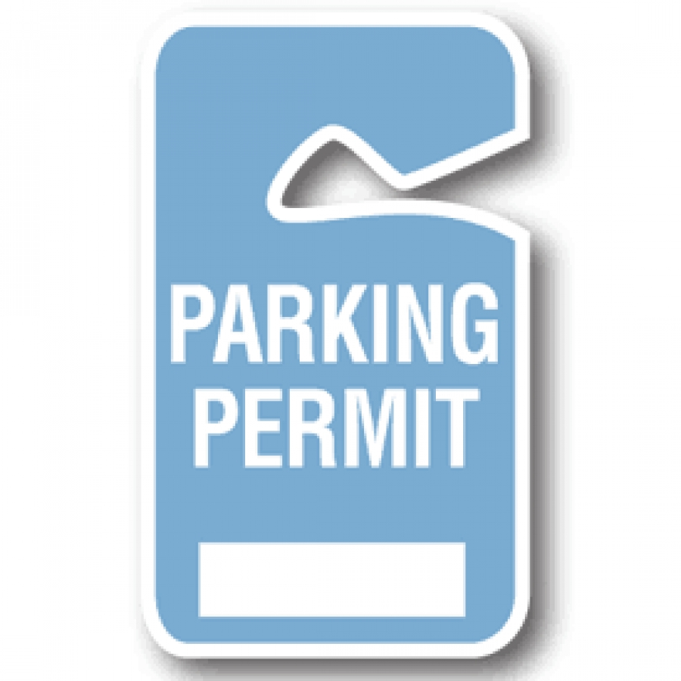

[](http://www.google.com/url?sa=i&source=images&cd=&cad=rja&docid=A22fzQSobsX3zM&tbnid=K_hLmWD-aOVpeM:&ved=0CAgQjRwwAA&url=http://www.pamsclipart.com/clipart_images/sparse_fir_tree_0515-1005-1302-1440.html&ei=b4RMUorIHuS9iwKj2IGgBg&psig=AFQjCNFuDOefTcWZYsE-Zrt2H_IJOgh6UQ&ust=1380832751634994)**The holiday season is coming soon so be aware that MAIL THEFT** becomes more common this time of year. USPS, UPS and Fed EX vehicles may be followed to steal packages left on doorsteps. You can discourage these thefts by checking your mail every day or have a trusted neighbor collect your mail & packages for you. Also consider your workplace, it may be a safer location to have packages delivered.

**Freezing weather** is coming soon. Drain and store your hoses. Insulate your outdoor faucets for the winter. Other winterizing tasks include weather stripping around doors and windows, cleaning your chimney and gutters, and furnace maintenance.



**The clubhouse** is available to rent for your winter events for only $25 per day. Use of the dumpster is an additional charge if needed and by request only. Call the office to schedule. Please follow Washington State’s Stay Safe Stay Healthy guidelines for group size, social distancing requirements. Sanitizing will be each renter’s responsibility.



Please check around your **water meter** and clear out grass, weeds, brush and trim overhanging branches. Your water meter readers will Thank you for making your meter more accessible.

**Thanksgiving Office Schedule** - The Rolling Hills-Glencairn Community Service office will be **closed** Thursday-Friday, November 26-27, so office staff may spend the Thanksgiving holiday with their families. We hope you have a Happy Thanksgiving as well. **Office hours are: 9am-2pm, Monday–Friday (unless otherwise posted).**



We’d like to welcome Netra to the RHGC community office. Ms. Kelly has resigned and is looking forward to her retirement!

****The next Board of Trustees meeting is scheduled for **Tuesday,** **November 10, 2020** at 7pm at the clubhouse. Members are invited to attend by appointment. Social distancing requirements will be met and masks worn.