**April 2022 Billing Newsletter**

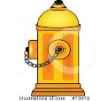**FULL SYSTEM FLUSH NOTICE & PROCEDURE.** Rolling Hills-Glencairn main water lines will be flushed on **Wednesday, April 20, 2022 and Thursday April 21**. A full system flush consists of closing and opening main water valves strategically throughout the community to run water through all the main lines and out the fire hydrants. This procedure cleans out all the water lines of sediment that can build up over time. **DO NOT USE ANY WATER** during the flush. You may have water in your home sporadically throughout the day but using it may only delay the restoration of supply to everyone.

If you use water during the flush, stirred up sediment may be pulled into your house. **When the flush is complete, we suggest you run an outside hose bib and let it run until you see that the water runs clear** (about 10 minutes).

Flushing begins at 8am and continues until about 5pm both days. The flush will end by 5pm both days. At the end of both days the signs will be removed from the entrances. Updates will be posted on the website rollinghillsglencairn.com

[](javascipt:void(0))H**iring-Pool Operator and Lifeguards** for the Memorial Day Weekend and the 2022 summer season. Lifeguard applicants must have a current lifeguard certificate or be able to certify, be reliable, responsible and at least 15 years old. Pool Operator applicants must be flexible, organized, teachable and a good leader. Pool chemical testing knowledge helpful. Please call the office at 360-678-7446 for more information.

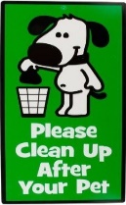The weather is improving and we’ve heard owners are leaving their dogs outside more. We have been receiving complaints about excessive dog barking, AGAIN! Please be mindful of your neighbors and let dogs in if barking.

**DOG POOP** - There is an extraordinary amount of poop on our roadsides and in the ditches. In some areas it is difficult for the meter readers to access the water meter boxes without dodging these messes. Every meter box must be physically opened, we don’t just do a drive by! All people walking in the community will appreciate clean roadsides too. Please pick up after your pet and dispose of it in your garbage can. **It is common courtesy to do so and rude not to clean up after your dog.**

The gate will be reinstalled soon. Parking passes and gate keys will be needed. If you have a gate pass and have changed vehicles or license plates please update the office via phone 360-678-7446 or email: [rollinghills@oakharbor.net](mailto:rollinghills@oakharbor.net) If you still need a gate key, contact the office.

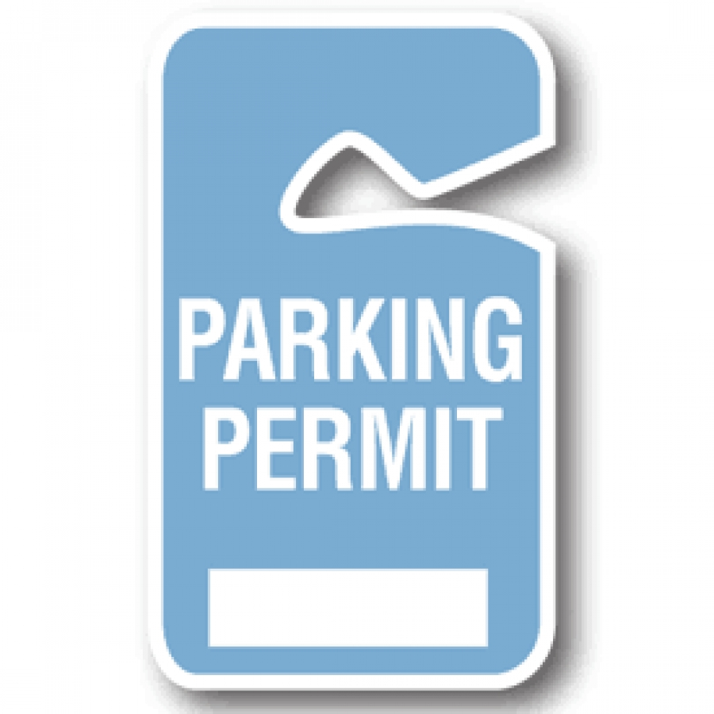

A big gray trash can was left at the beach but we have no service there. If you have large items please take them home for disposal.

A community Easter Egg Hunt on Saturday April 16th at Smith Park (950 SE Midway Blvd, Oak Harbor). 11:30 am is a sensory Friendly Egg Hunt - for children ages 1-10 (children with autism, special needs, etc). At 12:30 pm there’s Egg Hunt for age groups 1-3, 4-6, 7-10.

**Board of Trustee meetings are held the 2nd Tuesday of every month.** The next one is scheduled for Tuesday, April 12, 2022 at 7pm at the clubhouse. All members are invited and encouraged to attend. Board members positions are available if anyone is interested in volunteering.