**October 2020 Billing Newsletter**

**FULL SYSTEM FLUSH NOTICE & PROCEDURE.** Rolling Hills-Glencairn main water lines will be flushed on **Thursday, October 22, 2020**. A full system flush consists of closing and opening main water valves strategically throughout the community to run water through all the main lines and out the fire hydrants. This procedure cleans out all the water lines of sediment that can build up over time. **DO NOT USE ANY WATER** during the flushing. You may have water in your home sporadically throughout the day but using it will only delay the restoration of supply to everyone.

If you use water during the flush, stirred up sediment may be pulled into your house. **When the flushing is complete, we suggest you turn on an outside hose bib and let it run until you see that it runs clear (**about 10-15 minutes).

Flushing usually begins at 8-9am and continues until 5-6pm. You will know when the flush is completed when the signs are removed from community entrances and **if we have a current phone number on file for you in the office, you will receive a “Robo-call or Robo-text” from RHGC as the sender with the notification.**

**Beach parking lot gate**—Installation of the lock is moving forward. Your key card & parking pass will be included with a future billing prior to installation of the lock. The application is available at the office or **rollinghisllsglencairn.com**. Renters are required to receive keycards from their property manager. Be aware, you will need a key card for both entry and exit. Foot traffic will remain unrestricted.

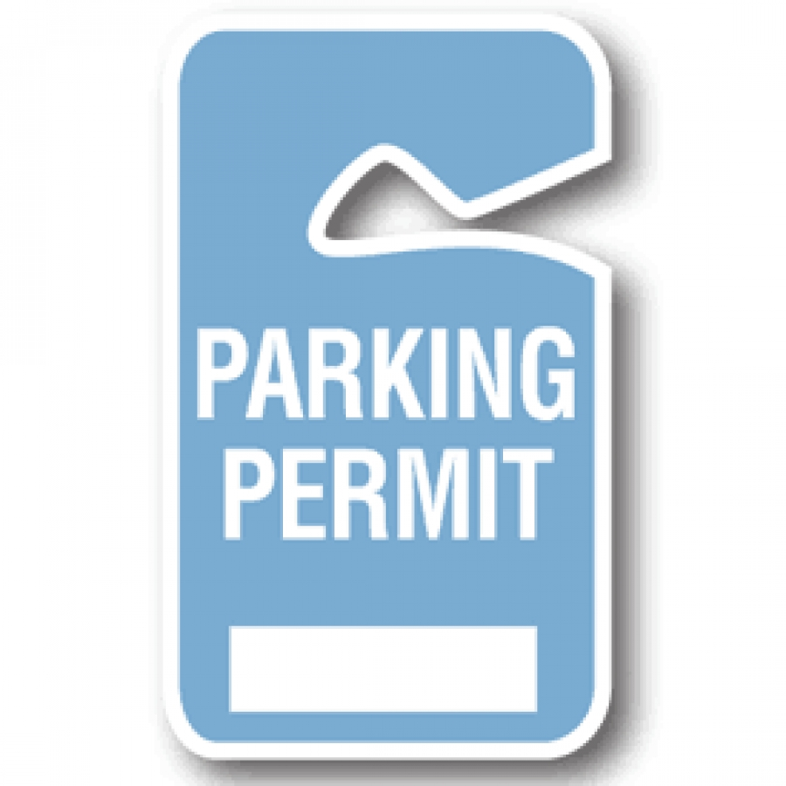

**Pier update:** The float was returned September 29th to the Coupeville Wharf for winter storage. The pier remains open for members and their guests.



**The Island County burn ban was lifted Oct 2, 2020.** Burning garbage or using burn barrels is illegal state wide. Find more details about outdoor burning and permits at [www.islandcountywa.gov](http://www.islandcountywa.gov).

Smoke and ash that unreasonably impacts your neighbors is prohibited, please keep this in mind when considering adding to the poor air quality from nearby wild fires.



The pool is now closed for the winter. We believe it was a successful year and gave many residents the opportunity to enjoy a safe recreational activity during this summer of many restrictions. Thank you all for your kindness & support, we really do live in a great community.

MCj03126680000[1]The windy season has started and power outages can be expected. During a power outage your water pressure will be lower than normal. (Normal is 60-75 PSI, during an outage it may be 26-30 PSI) It is only enough for a drink, water on hand and a slow refill of a toilet. In the event of a long term outage, please use water only as necessary and do not expect to have unlimited access.

****The next Board of Trustees meeting is scheduled for **Tuesday,** **October 13, 2020** at 7pm at the clubhouse. Members are invited to attend if the office is notified in advance. There will be social distancing and masks worn.